To Demonstrate how the Equation of a Circle changes as the Radius changes.
- If GeoGebra is not already on your computer go to www.geogebra.org and download the free program. Also note your computer needs to have an updated version of Java available free at http://www.java.com/en/.
- Open GeoGebra. If one of the areas in the diagram below does not appear and you require it go to View and select the relevant area.

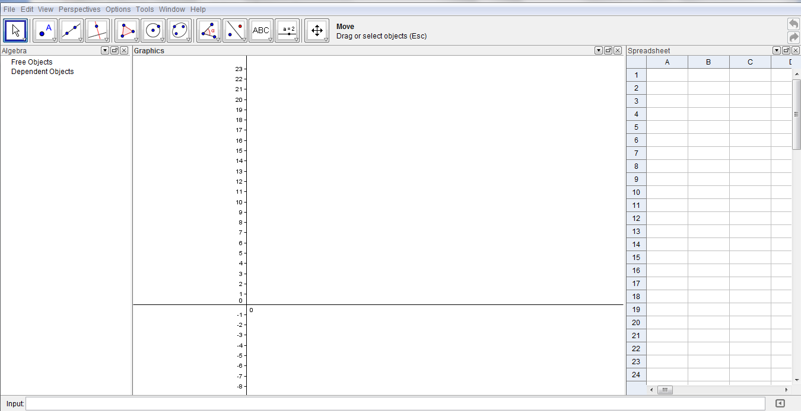
Algebra
Spreadsheet
Input Bar
Graphics

- Go to the slider tool 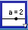 and click on the Graphics.
- A new window appears.
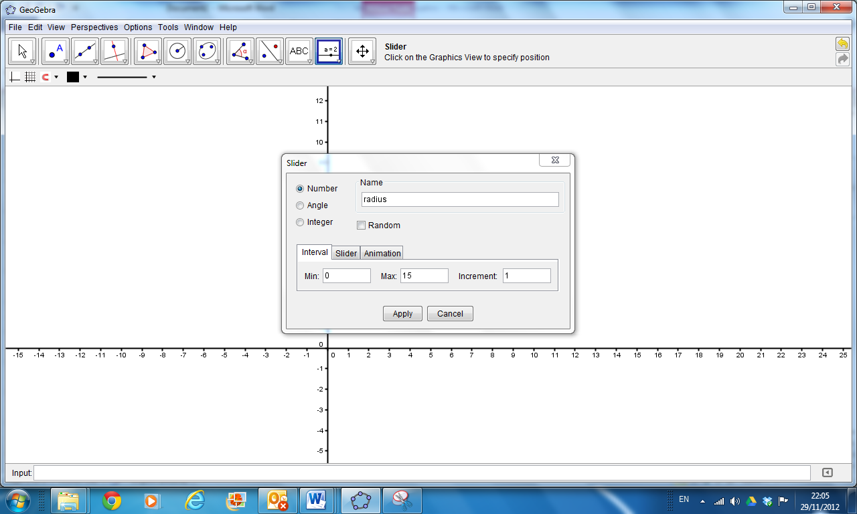
- Change the name to radius, Min to 0, Max to15 and Increment to 1.
- Click Apply.
- In the Input Bar type (3, 2). (Note if the Input Bar does not appear at the bottom of the screen, go to View, Input Bar and click Show.) Alternatively this could be (0, 0) or any other point that you want to be the centre of the circle.

- Right click the point A, choose Object Properties and with the Basic tab open click Fix Object.
- Click on the Circle with Centre and Radius tool 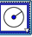.
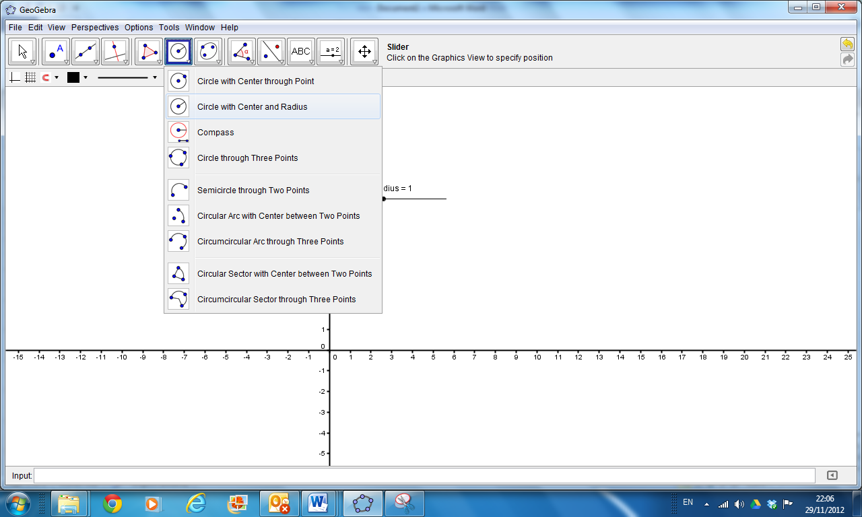
- Click on the point (3,2) or whatever point you want the centre of the circle to be.
- A new window appears.
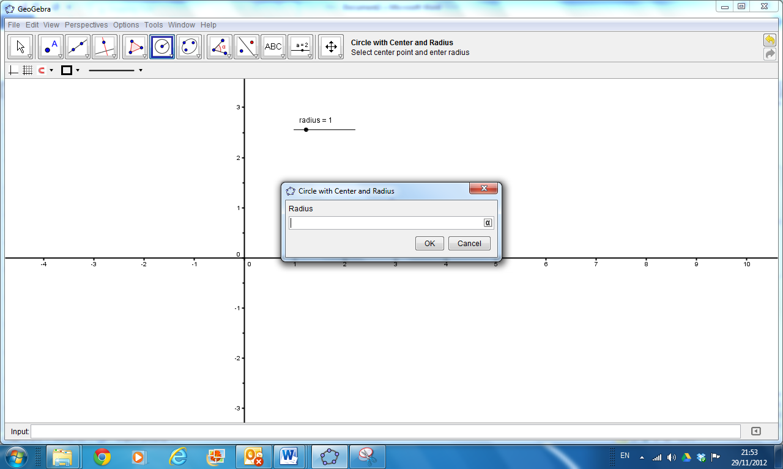
- In this window type radius the name of your slider from step 5 in the box for Radius and press OK.
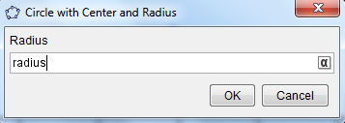
- Right click on the circle and choose Object Properties.
- With the Basic tab open Choose Name and Value so that when we change the radius later we can see what happens the equation.
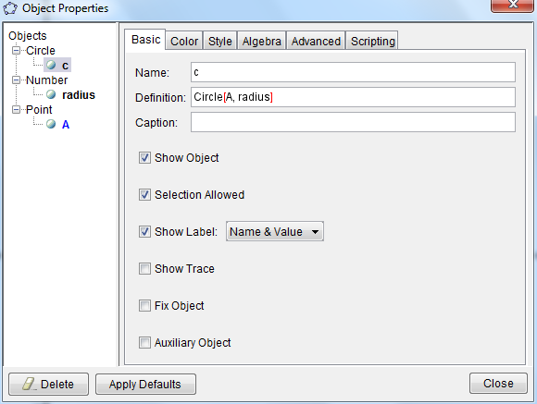
- With the Color tab open choose the colour of your choice and with the Style tab open pick the Line Thickness etc.
- Click Close.
- Click on the Move tool 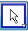 . Move the slider and see the circle and corresponding equation change.
- If the circle does not fit on the screen choose the Zoom Out tool and click on the Graphics.
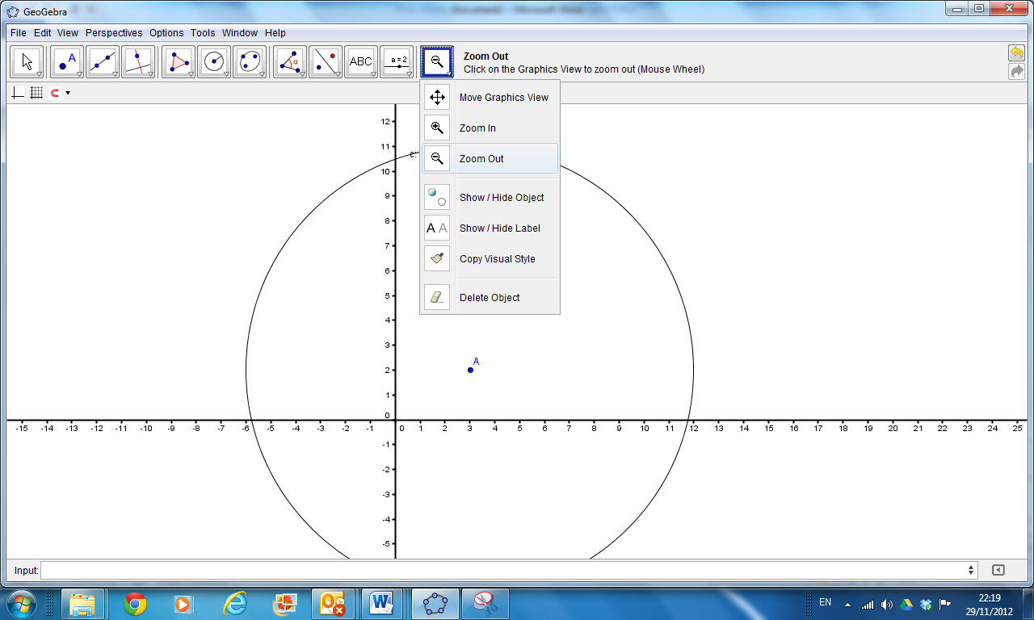
- Go to File and choose Save and a new window appears.
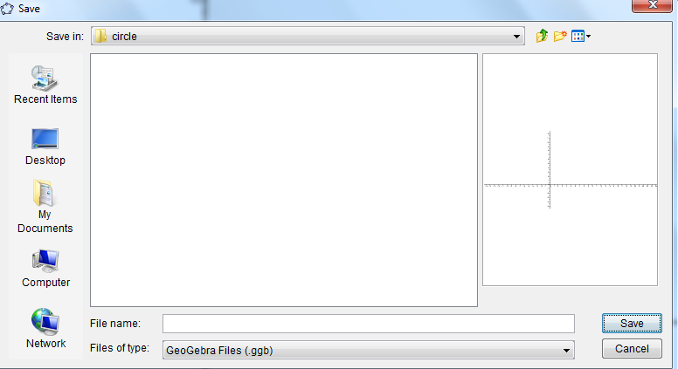
- Opposite File name type the name you want to give your file. Choose the location you want to save the file, for example My Documents.

